A Quick Guide to Using Canvas Outcomes for Assessment Purposes
- Create Outcomes for the course. These can be course-level, program-level, and/or institution-wide outcomes. See Appendix A for comments on settings.

- Identify the Quizzes / Assignments you’d like to use to measure student performance on these Outcomes. Often, faculty choose a final project or final exam.
  - If the Quiz is in Classic Quiz format, it must be migrated to New Quizzes to avoid the time-consuming process necessary to assign Classic Quiz questions to Outcomes.
    - Double check questions on migrated quizzes to ensure they’ve transferred correctly.

- Align the assessment assignment(s) with the Outcome(s).
  - Quizzes: In the New Quiz format, align each quiz question with an Outcome.
  - Assignments: add Outcomes to Assignment rubrics. See Appendix B for considerations.

- View outcome results via the Gradebook (Gradebook > Learning Mastery). See Appendix C for more details on reading Gradebook reports.
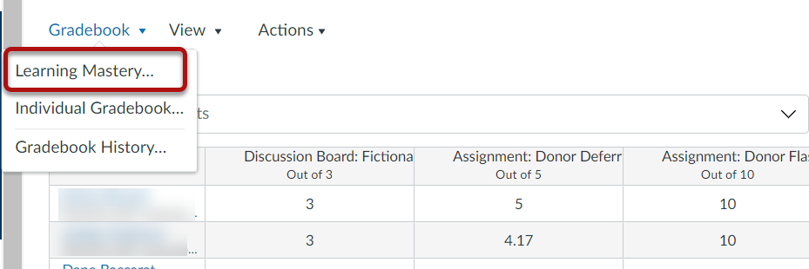

Suggestions for Streamlining
- Consider using only the final assignment / exam to measure student success on Outcomes.
- Department Chairs can set Outcomes for all courses in their sub-accounts, such as PSLOs or ISLOs.
- Department Chairs can pull Outcomes reports for all courses in their sub-accounts. The Reports arrive in an Excel spreadsheet, and the data can be sliced to reveal just one Program’s outcome results, for example.
Quick Guide to Using Canvas Outcomes for Assessment Purposes
Appendix A: Outcome Settings (see screenshot, next page)
[1] The “Friendly Name” is the name students will see. For example, a one might refer to numbered outcome 1.1 as “Customer Service.”
[2] Proficiency Ratings are often set out of 100 (for simplicity’s sake) or out of 4 points (for consistency when intended for a rubric with other 3- to 5-point categories). A ratings scale of 100/75/50/25/0 is the same as a scale of 4/3/2/1/0.
[3] Mastery and Proficiency Ratings are reported separately, so they can be used to gain additional data. Provided that the ratio between Mastery and Proficiency Ratings remains the same, the specific point scale is immaterial. For example, let’s say that a program sees 82% as a benchmark it would like to measure. Setting the Mastery points at 82 for a 100-point Proficiency Rating scale is the same as setting Mastery points at 3.28 for a 4-point scale.
[4] The Calculation Method can be set as a decaying average (scores for more recent assignments are weighted more heavily), most recent, or average. If only one assignment is used to assess student performance on Outcomes, the Calculation Method is immaterial.
Numerical Settings
There is no one right set of numbers to assign to Outcome Proficiency Ratings or Mastery points. These numbers will depend entirely on what, exactly, you want to measure. Here are some basic guidelines to set numbers to get the data you want:
- Proficiency Ratings provide the opportunity for gathering more detailed data than the set Mastery point. Multiple criteria can allow you to see how many students are close to proficient (and thus may benefit from small interventions) as opposed to absolutely terrible.
- That said, if all you want is a simple count of how many students reach mastery, no need to create multiple Proficiency Rating criteria.
- Mastery should not be set at the same number as the highest Proficiency Rating unless 100% perfection is required for Mastery.
- If Outcomes will be used on rubrics (whether calculated into the rubric score or not), consider setting point values at what would be appropriate for the rubric.
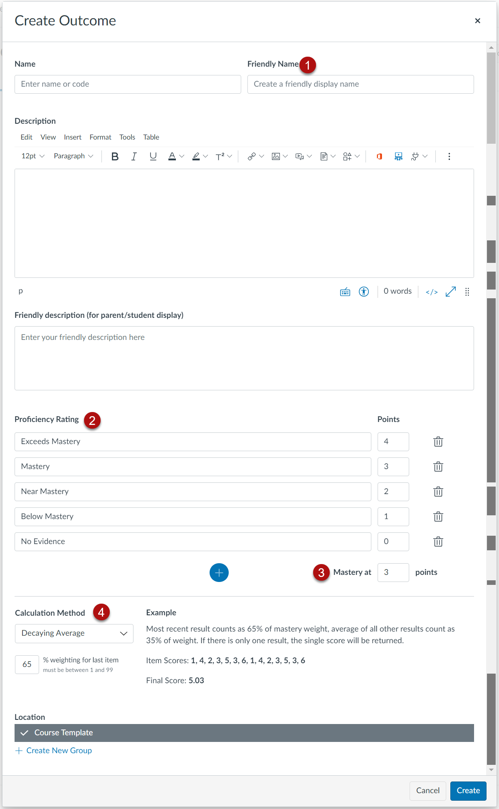
Quick Guide to Using Canvas Outcomes for Assessment Purposes
Appendix B: Adding Outcomes to Rubrics
There are a few things to consider when adding Outcomes to rubrics (which, in turn, are attached to Assignments, Quizzes, or Graded Discussions).
- Students will see the Outcome(s) on the rubric. Thus:
  - It may be clearer to students if the Proficiency Ratings are similar to other rubric items. If the rubric item “thesis” has 3 available points, it may be confusing to have an Outcome listed with 100 points.
- Outcomes do not have to be calculated as part of the rubric score. Thus:
  - It may be useful to inform students when (and why) there are items on the rubric that are not part of the final rubric score.
- Outcomes do not offer the same level of detail as other rubric items. Rubric criteria can include additional specifics to help students understand why they earned the scores they did. However, Outcomes added to rubrics only include the Proficiency Rating categories (see below).
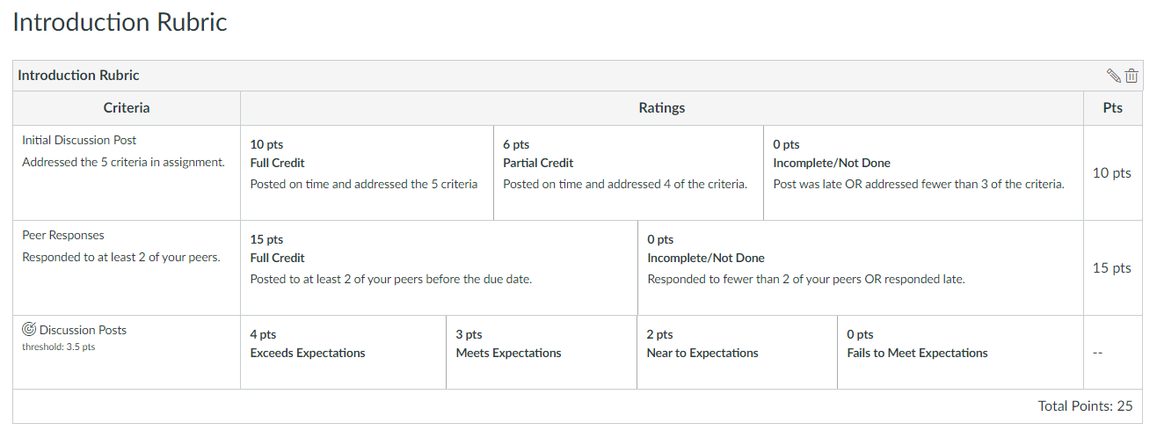
In the rubric above, the criterion that is an Outcome is denoted by the bulls-eye symbol next to the criterion name (“Discussion Posts”). Additionally, this Outcome is not included in the rubric score. For this Outcome, Mastery is set at 3.5 out of 4 points.

Quick Guide to Using Canvas Outcomes for Assessment Purposes
Appendix C: Interpreting Results
The Outcomes results in the Canvas Gradebook will depend upon the values assigned to the Outcome’s Proficiency Rating, Mastery points, and Calculation Method. The goal is to set those values such that the Gradebook reports provide the data you want.
Let’s say we have the following settings for Outcome 1:
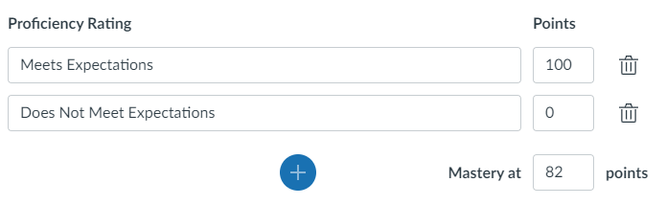
Here’s how to read the Gradebook reports for these point values: 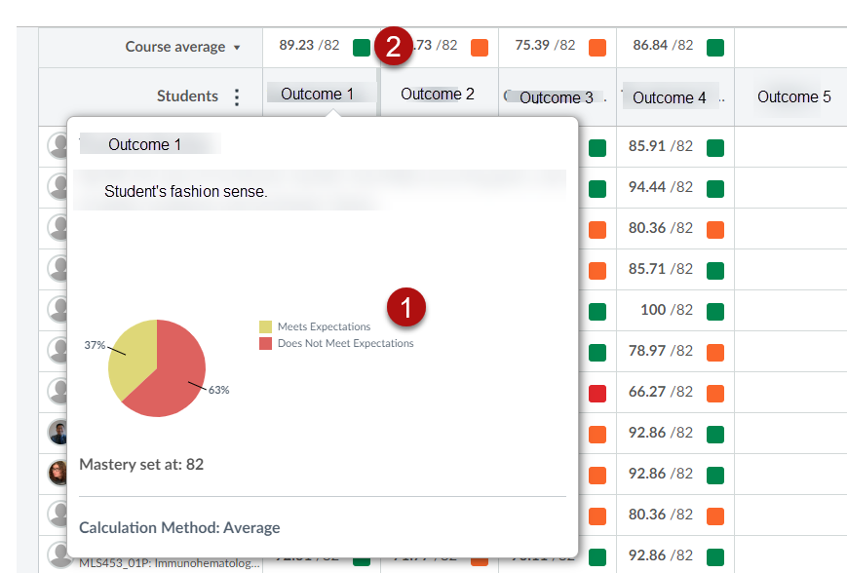
[1] 37% of students Meet Expectations (100/100) for Outcome 1.
[2] The course average for Outcome 1 is 89.23%. Since this average exceeds the Mastery cut-off (82/100), the box is green (green = good).
To identify how many students meet Mastery, the instructor would need to count the number of students whose scores are 82 or higher.

If the intent is to calculate Mastery at 82%, and if Mastery is synonymous with Meets Expectations, the Outcomes Proficiency Ratings might instead be set thusly:
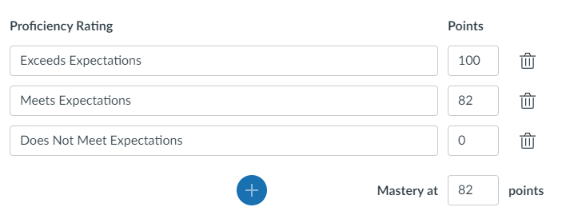
The same Gradebook would now produce the following reports:
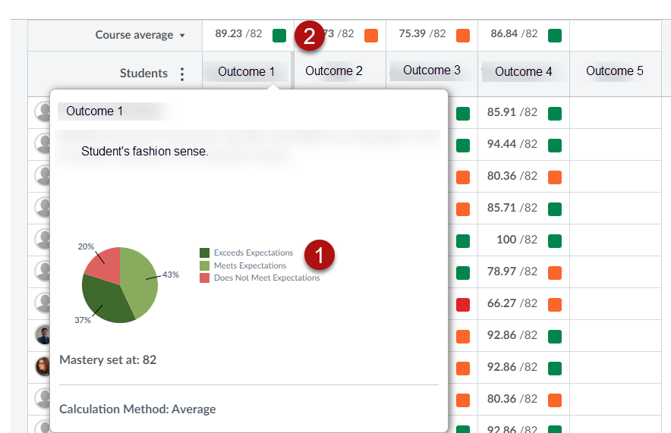
[1] 80% of students either Meet or Exceed Expectations (at least 82/100) for Outcome 1.
[2] The course average is 89.23%. Since this average exceeds the Mastery cut-off (82/100), the box is green (green = good).
To identify how many students meet Mastery, the instructor could count the number of students whose scores are 82 or higher. OR, the instructor could multiply the total number of students in the course by 80%.

Let’s say that the instructor wants to include this Outcome on a rubric, the other criteria on which use a 4-point scale. Also, the instructor would like to know how many students achieve at least 75% (3/4 or “Acceptable”) in addition to how many achieve Mastery (still set at 82% or 3.28/4). 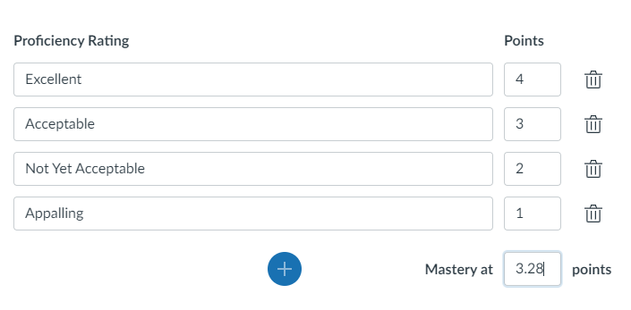
In this case, the same Gradebook would show the following reports:
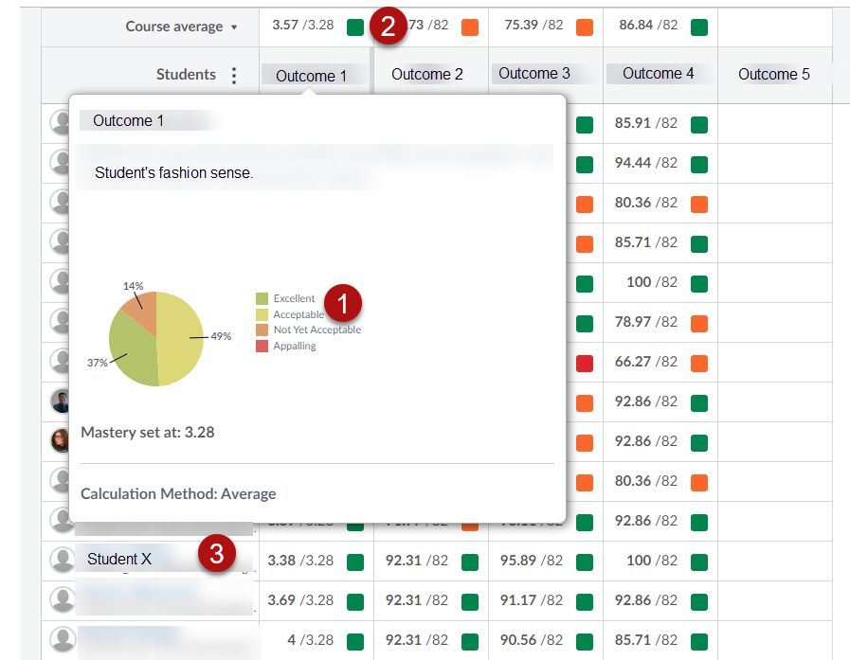
[1] 86% of students achieve at least 75% on Outcome 1.
[2] The course average is 3.57/4 (still 89.23%).
[3] The students’ scores for Outcome 1 are now listed out of 4 points possible.
To identify how many students meet Mastery, the instructor could count the number of students whose scores are 3.28 or higher.

