Add Zoom to Studio Cloud Recordings
1. Open Canvas, and click on the Studio tab in the vertical Global Navigation Menu on the left.
2. Expand the “hamburger” menu in the upper left.
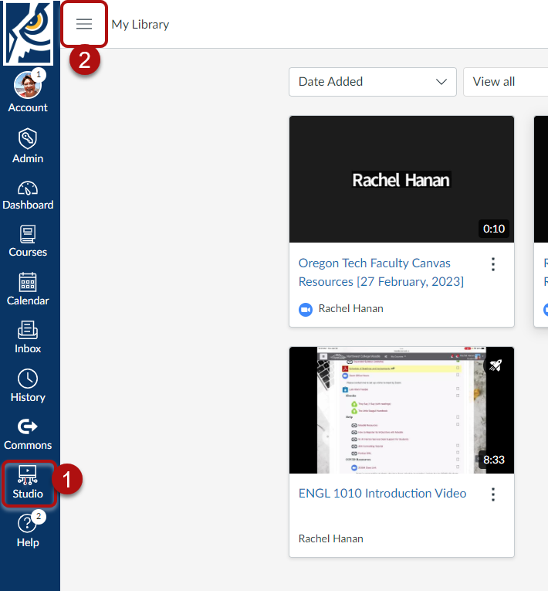
3. Click on the Conferences tab in the horizontal menu along the top.
4. Click Zoom User Authentication.
5. Click Continue.
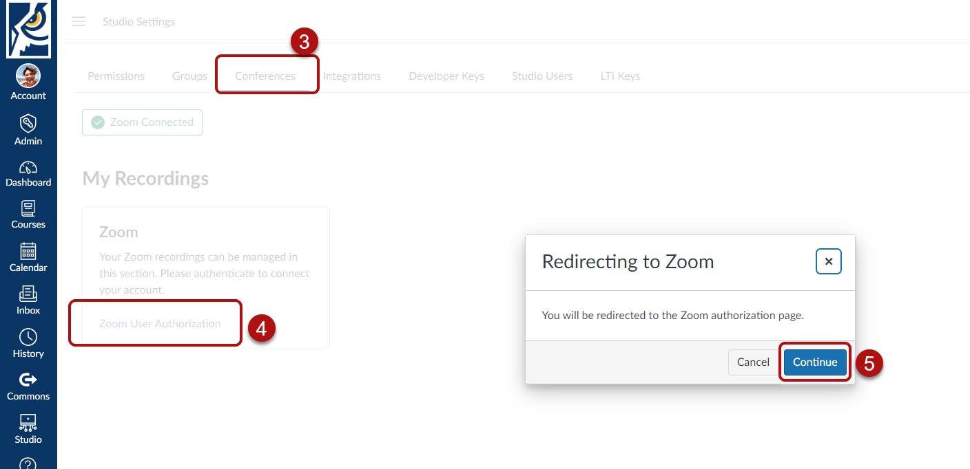
6. When signing into Zoom, be sure to use the SSO (single sign on) option.
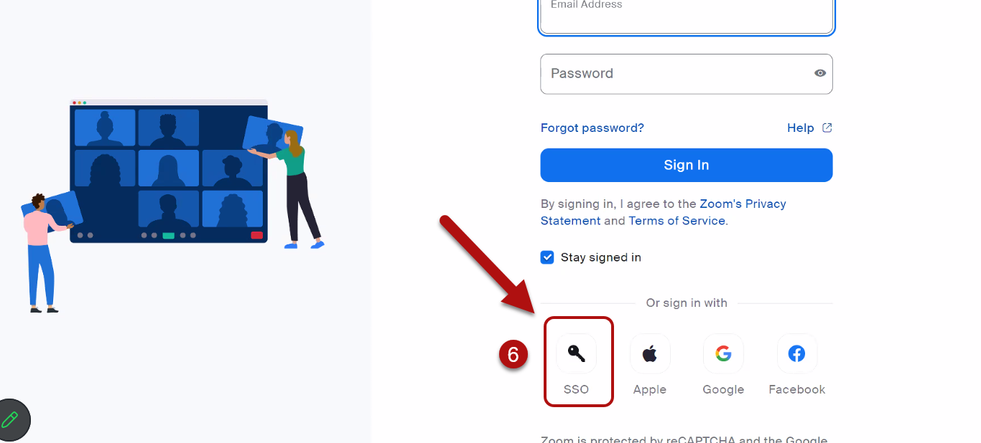
7. Our company Domain is “oregontechonline.” Click Continue.
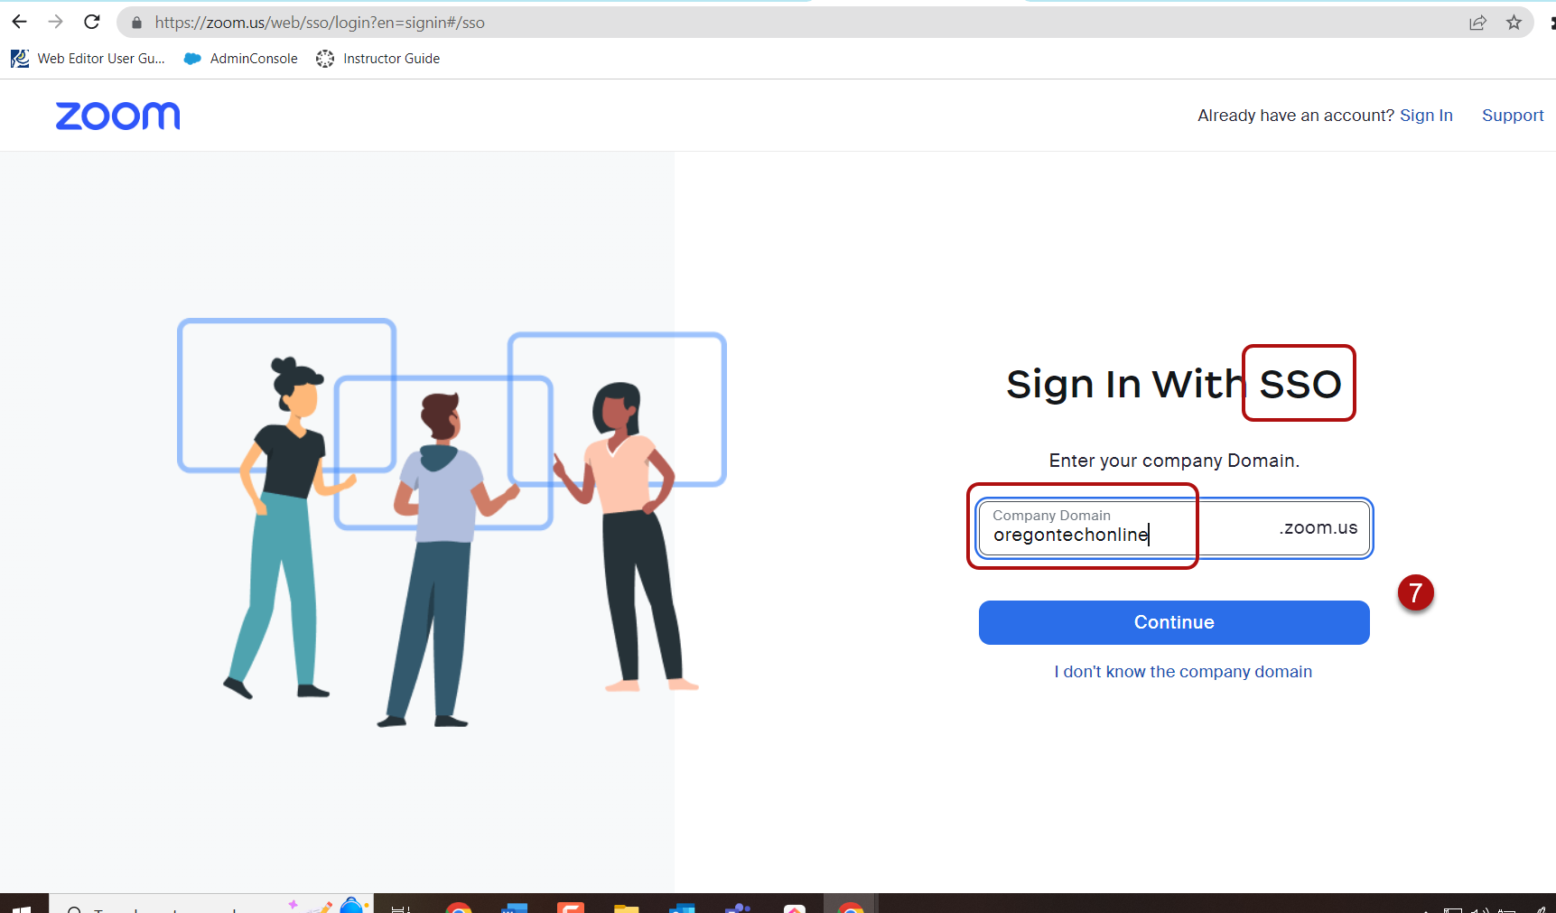

8. Check the box to allow Zoom Studio Cloud Recordings to access your permissions.
9. Click Allow.
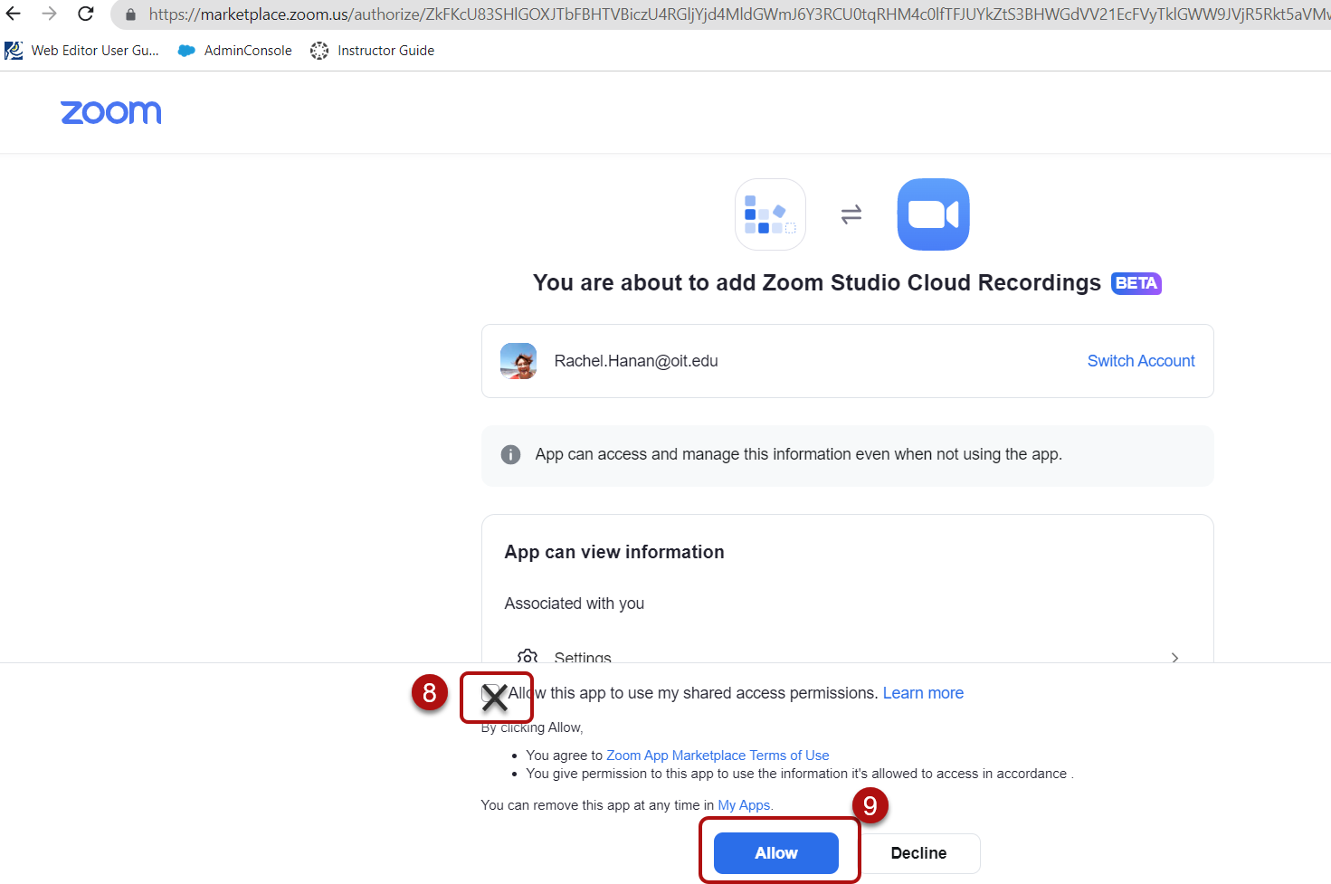

Note: Some users are getting an error message at this stage. So far, it looks like repeating the process half a dozen times or so (starting at step 4) eventually works.
10. When your Zoom is integrated with Studio, here’s the screen you should see. Toggle the button to save Zoom meetings to Studio automatically.
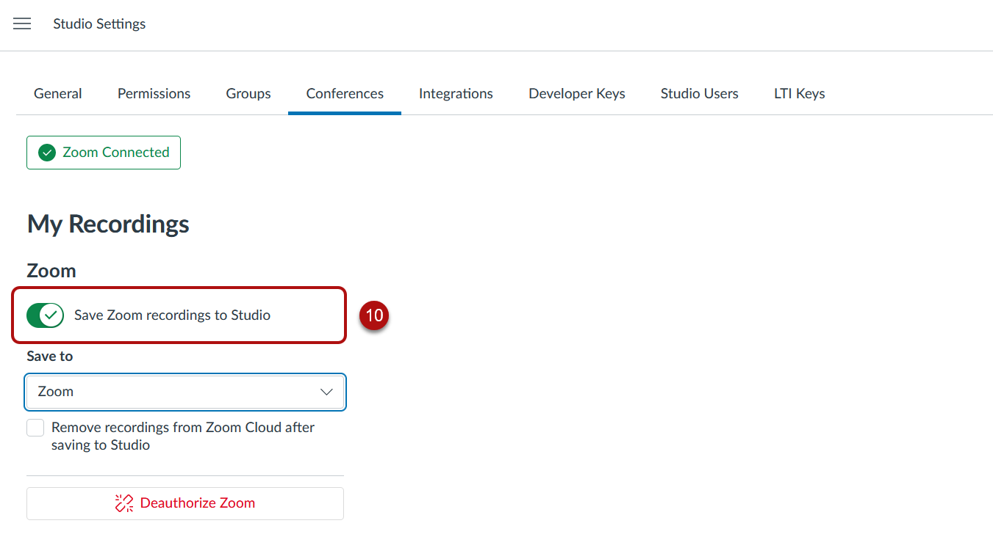
NOTE: If you do not have the option to save Zoom recordings to Studio, go to your Zoom account at www.zoom.us and login through the blue My Account button in the upper right. You may need to use the SSO option, with the domain name “oregontechonline.” Once in your account, choose the Settings tab on the left, and the Recording tab along the top of the screen. Make sure that the button to allow cloud recording is toggled on.
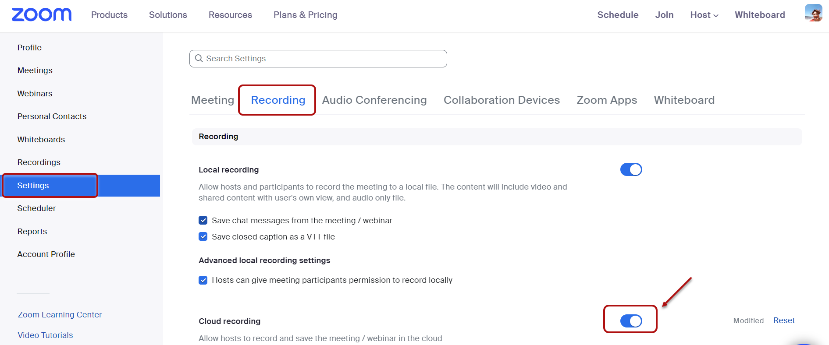

11. Designate where you’d like to save your Zoom recordings in your Studio library. Helpful Hint: consider creating a New Collection for to each course and using consistent naming conventions so you can easily browse through the many videos you’ll accumulate.
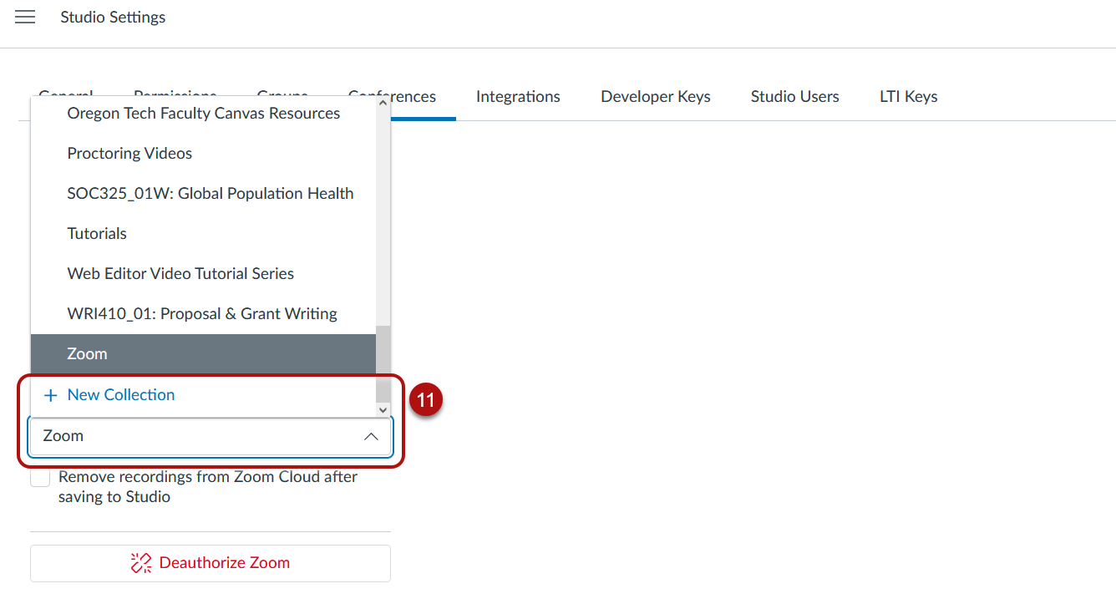

Next Steps
Ensure that Zoom is enabled in your Course Navigation Menu. This way, you can schedule Zoom meetings directly within the course; students will be notified, and the meeting will appear on their Canvas calendars and to-do lists.
1. Within the course, click on the Settings tab in the Course Navigation Menu.
2. Click the Navigation tab across the top.
3. Drag and drop the Zoom block up to the Course Navigation block. – OR – Click the three dots on the Zoom block and select “Enable.”
4. Don’t forget to save at the bottom of the page!
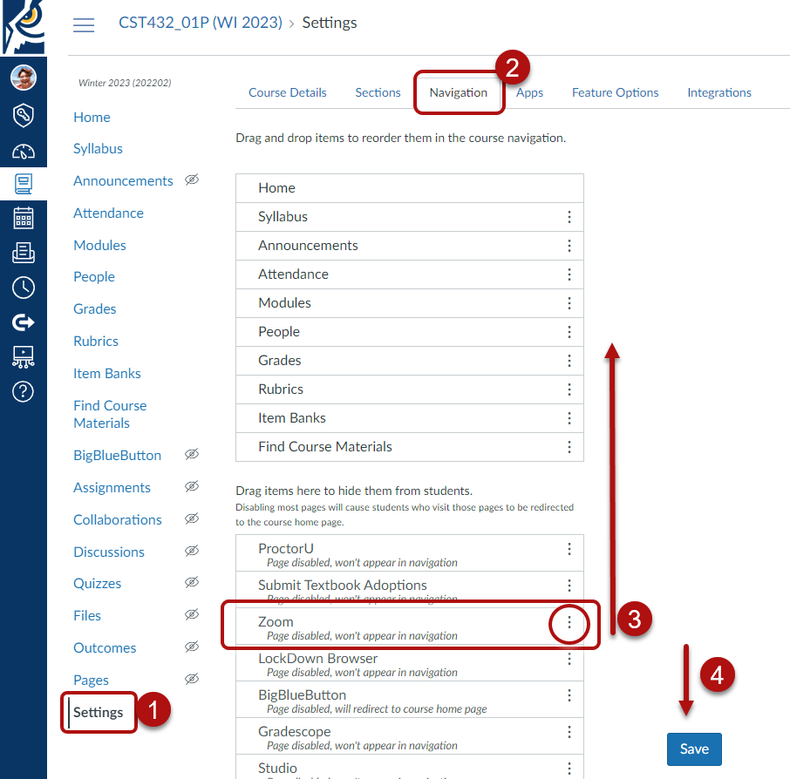

Schedule Zoom meetings so students are notified of the meetings and they show up on students’ Canvas calendars.
1. Within the course, click on the Zoom tab in the Course Navigation Menu.
2. Click Schedule a New Meeting.
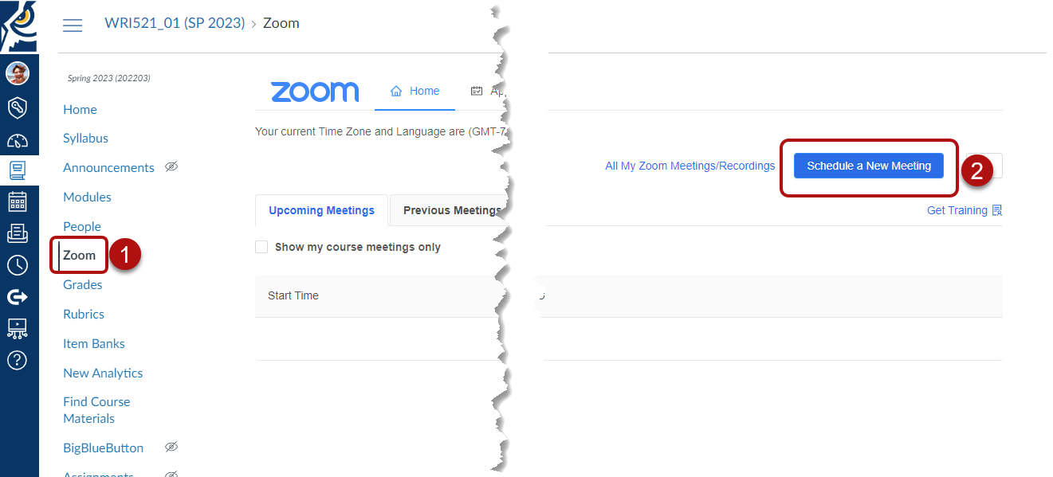
Meetings can be recorded automatically so that you don’t have to remember to record lectures.
3. Opt to record the meeting automatically.
4. Record it to the cloud, where it will be saved to your Studio account.
5. Don’t forget to save.
